**CHAPTER 3:**

**METHODOLOGY**

# 3.0 Introduction

According to Davis G.B etl (1985) defines a methodology as a system of principles, practices, and procedures applied to a specific branch of knowledge.” In this section, a way of how the objectives stated in subsection 1.3 will be achieved is presented. Section 3.1 presents research design, section 3.3 discusses sampling size, section 3.4 discusses sampling technique, and section 3.5 presents data gathering techniques and finally section 3.7, which discusses system modeling and design.

* 1. **Research Design**

The research design of this research was based on structured system analysis and design methodology (SSADM) along with SDLC. This describes how the objectives were achieved. This includes the tools, techniques and methods that were used in the data collection, analysis, design and implementation of the system. The modelling process used with both data and process modelling

* 1. **Target Population**

The target population and major beneficiaries of this project will be the students and staff of Muteesa 1 Royal University.

* 1. **Sample size**

The sample size was selected from four faculties at Muteesa 1 Royal University. The faculties in the study were Faculty of Science Engineering, Faculty of Social Sciences, arts and Humanities, Faculty of Education and Faculty of Business Management. The researcher used a sample of 100 individuals of which 20 were fresh students who did not know about research projects, 33 were second year students who were also not sure about the process of research project management and 47 were final year students who were actively doing their research projects at the university. In total, the research engaged a total sample size of 47 students guided by the use of purposive sampling.

**3.4 Sampling Technique**

The researcher had two techniques in mind, i.e. probability or non-probability sampling but opted for probability sampling which according to him would give more accurate findings hence, less margin of error. Probability sampling was done in a way that the researcher picked respondents randomly without following a particular pattern

# 3.5 Data gathering Techniques

This sampling technique enables the researcher choose the sample set to use based on best technique to collect data and come up with the new proposed system. Among the data gathering techniques include the following;

## 3.5.1 Questionnaire

The researchers used questionnaires as a method of gathering information. This was done by preparing some relevant questions on a questionnaire which were distributed MRU students to fill in relevant answers. The researcher used open and closed ended type of questions. These Questionnaires would be use because of the following reasons; No bias for the respondent and it helps to avoid embarrassment on the side of the respondent for example in case the student is not sure of the answer.

## 3.5.2 Interviews

Interviews were carried out in order to obtain information on the technical aspect of the problem at hand. Interviews were conducted with different student at the campus from different departments since all departments and faculties do research as a requirement at the university. Questions on how they use the new system if implemented were considered. They include structured, unstructured or semi structured questions. They were semi guided and unguided. Both closed and open ended questions will be used to acquire the data.

This helped the researcher to get current information about what the students expect out of the new system and it gains a full range and depth of information that one can express all his or her feelings about a subject.

It creates a relationship between the researcher and stakeholders which is good for further inquiries and references.

## 3.5.3 Document review and written literature

A lot of Literature is looked at in order to enrich the sources of information for the study. This is done by reviewing the documents and written literature other scholars have written down about other online research project information management system projects and systems for the past years. Through the use of written material in form of literature books, internet materials and journals and be able to gather information on concepts and challenges of the current proposed systems.

|  |  |  |
| --- | --- | --- |
| No | Objectives | Tools and techniques |
| 1. | To carry out a thorough system study of the current system in order to determine the user requirements of new system. | * Document Review * Questionnaire |
| 2. | To design a management information system that meets user requirements. | * Use Case Diagram * DFD * Conceptual design * ERD |
| 3. | To implement a online research information management information system. | * PHP * JavaScript * HTML * MySQL (backend database) |
| 4. | To validate the system to ensure that it meets the user requirements. | A technical team and End users (students) will interact with the system to ensure that the system meets the user requirement using a set of guidelines. |

Table 1: Document Review Table

# 3.6 System and Data Analysis

The Purpose of the study was to get a clear picture of what the system performs. The system analysis involved a detailed study of the various operations performed by the current system and their relationships within and outside the system. During this process, data collected on the available files and transactions handled by the current system. System Analysis involved collecting data, understanding the processes involved and identifying the problems of the current system. This also involved studying the business processes, gathering operational data.

**3.7 Modeling, design, and system development tools.**

System modelling will show the system data requirements, model the entities and the structure of the relations in the relational schema of the database.

## System modelling key modules

**Entity:** This is a source and destination of data within the system. This shows the major units which are combined within the system.

**Data store:** This contains or stores the data which is entered into the system. It is a data repository of a set of integrated objects. These objects are modeled using classes defined in database schemas. Data store includes not only data repositories like databases; it is a more general concept that includes also flat files that can store data.

**Process**: in a process, incoming data flows are processed or transformed into outgoing data flows; they portray the transformation of input data flows to output data flows in DFDs.

**Table showing the key modules diagrammatically.**

|  |  |
| --- | --- |
|  | **Entity** |
|  | Process |
|  | Data Store |
|  | Report |

Table 4: Modelling Components.

## 3.7.1 Context Diagram

This is a system overview showing the system boundaries, external entities interacting with the system and major information flows between entities and the system. This diagram shows the overall context of the system with the external entities interact with the system.

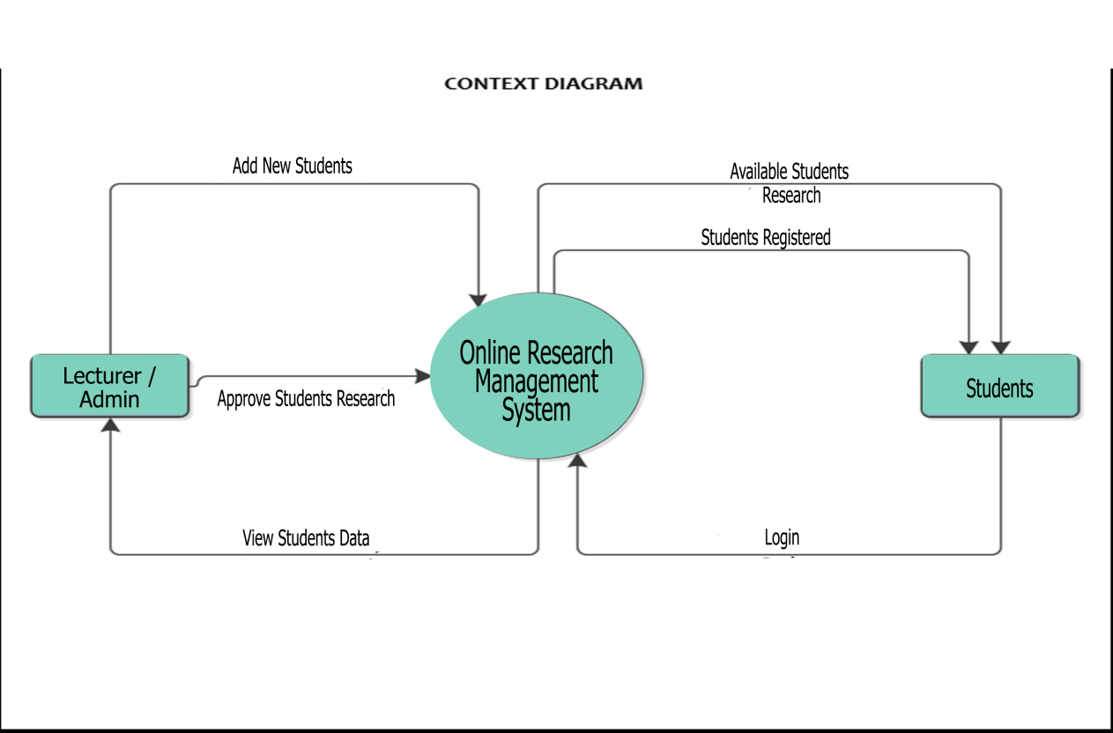

**Figure 1: Context Diagram**

## 3.7.2 Use case Diagram

The figure below shows the different actors of the system and what each actor of the system does and performs on the system

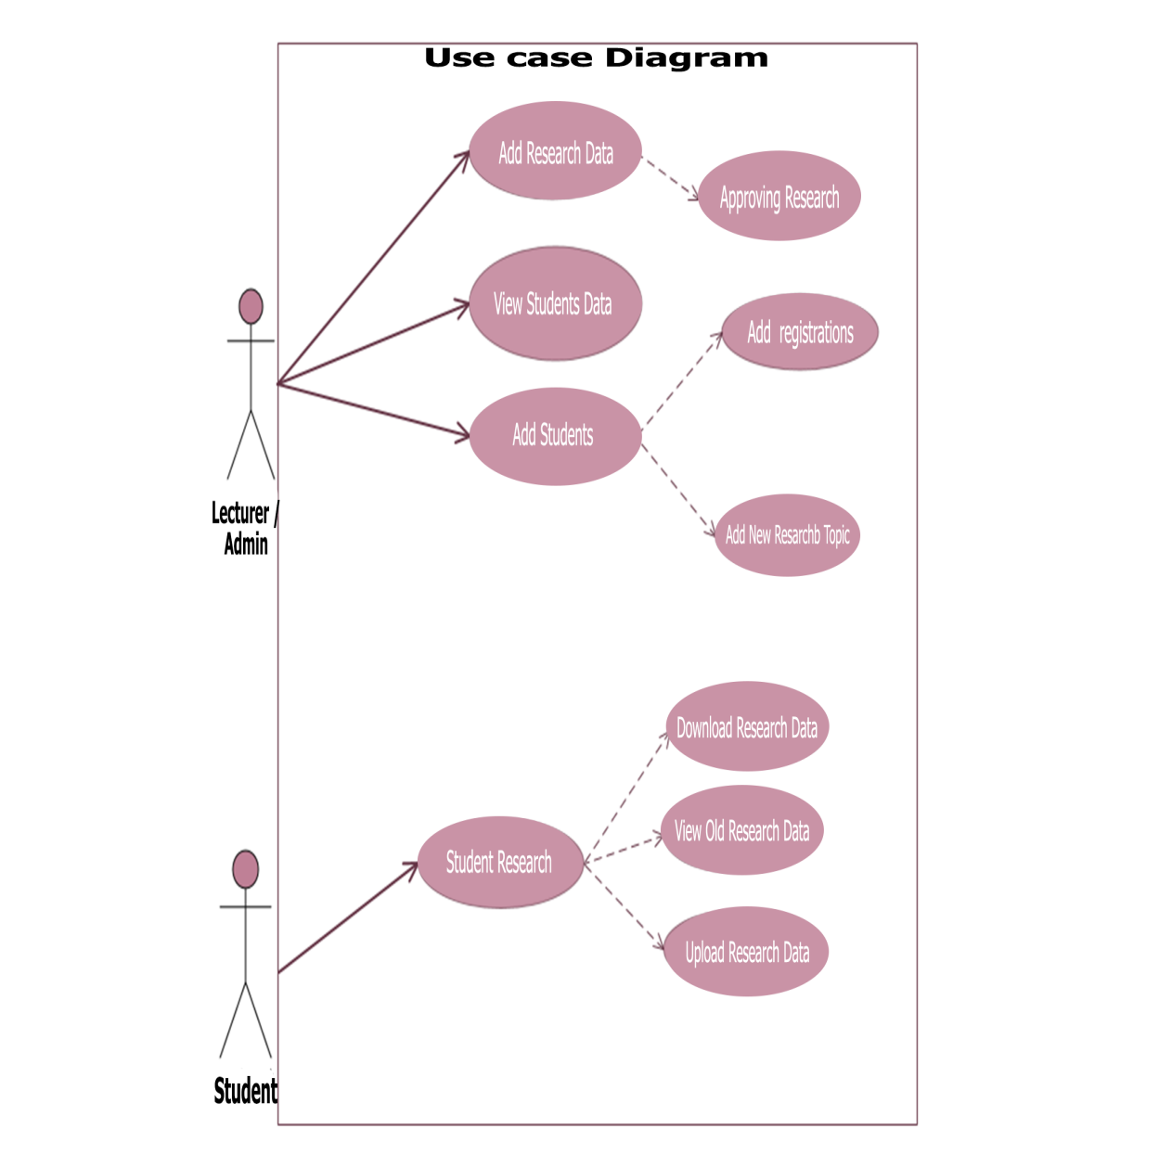

**Figure 2: Use Case Diagram**

## 3.7.3 Data Flow Diagram (DFD)

This is a diagram which shows how data moves and changes through an Information system in a graphical top-down fashion. Or the graphical representation of a system’s components, processes and the interfaces between them and the way how they relate with each other.

View list of created student project repositories

Run a search query through available student repositories

Add new Student

Delete student account from the system

Add files to ORMS library

Delete files from ORMS library

**START - ADMIN**

**LOGIN**

User permission to delete files from the repository is available for the administrator module

Explore research repository

**Figure 3: Data flow Diagram**

# 3.8 Conclusion

This chapter has discussed the methodology of the system through research design, target population, sample size, data collection techniques. It has also discussed the system analysis, and data sampling techniques, plus modeling and system development tools which are to be used of develop the system required.